Database Management System Lab

KCS 551

## Bachelor of Technology

#### in

Computer Science and Engineering



Submitted To: Submitted By:

Mr. Punit Kr. Chaubey Ravi Prakash 2204220109038 SECTION – CSE 3 B

Bansal Institute Of Engineering and Technology,

Lucknow

(Dr. A.P.J. Abdul Kalam Technical University, Uttar Pradesh)

## INDEX

|  |  |  |  |  |
| --- | --- | --- | --- | --- |
| SR.NO. | Experiment Name | Page No. | Date | Teacher’s Sign |
| 01. | Installing Oracle/MySQL. | 01 | 20-09-2023 |  |
| 02. | Creating Entity-Relationship Diagram using case tools . |  |  |  |
|  |  |  |  |  |
|  |  |  |  |  |
|  |  |  |  |  |
|  |  |  |  |  |
|  |  |  |  |  |
|  |  |  |  |  |
|  |  |  |  |  |
|  |  |  |  |  |
|  |  |  |  |  |

Experiment No – 01

#### AIM: Installation of MySQL

Step 1: Make sure you already downloaded the MySQL mysql-installer-web- community-8.0.34.0.msi file. Double click on the .msi file.



Step 2 :This is mysql-installer-web-community-8.0.34.0.msi. The setup wizard will install mysql-installer-web-community-8.0.34.0.msi on your computer. To continue, click next.Choose the setup type that best suits your needs. For common program features select Full and it’s recommended for general use. To continue, click next.

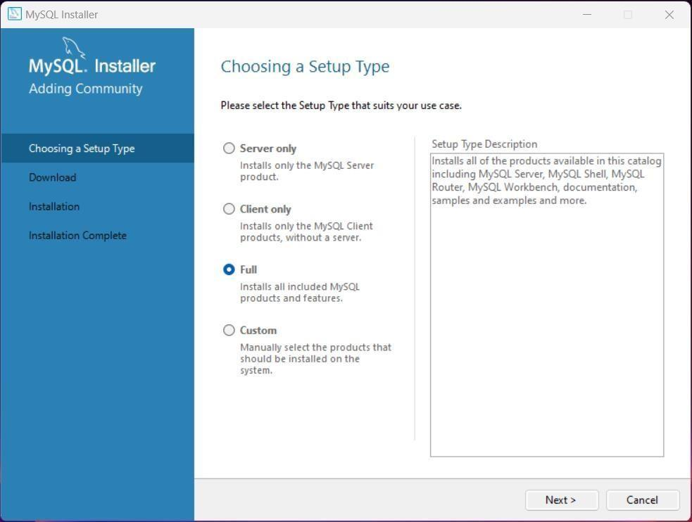

Step 3 : This wizard is ready to begin download. Destination folder will be in C:\Program Files\MySQL\ MySQL Server 8.0 To continue, click next.

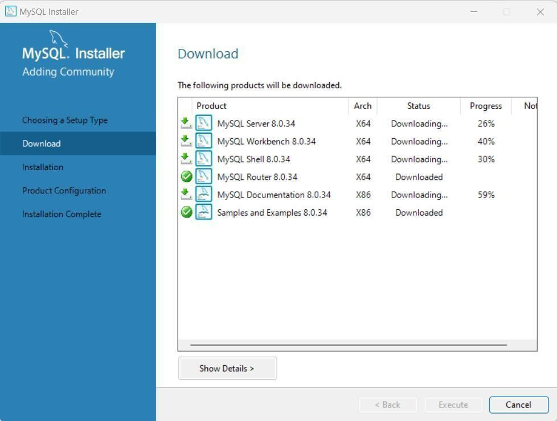

Step 4 : The program features you selected are being installed. Please wait while the setup wizard installs MySQL 8.0. This may take several minutes.Click on next .

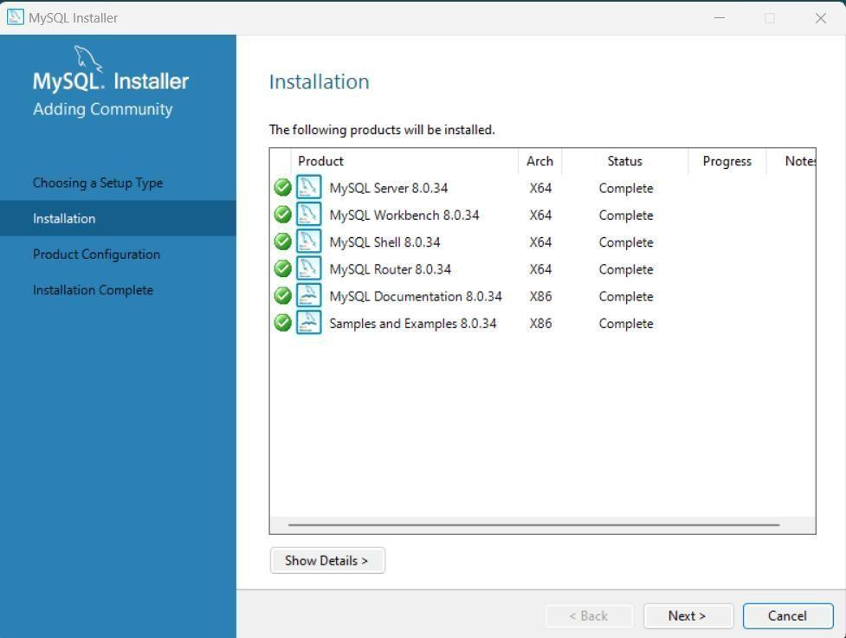

Step 5 : To continue, click next until you get this page. Please set the security options by entering the root password and confirmretype the password. continue, click next.

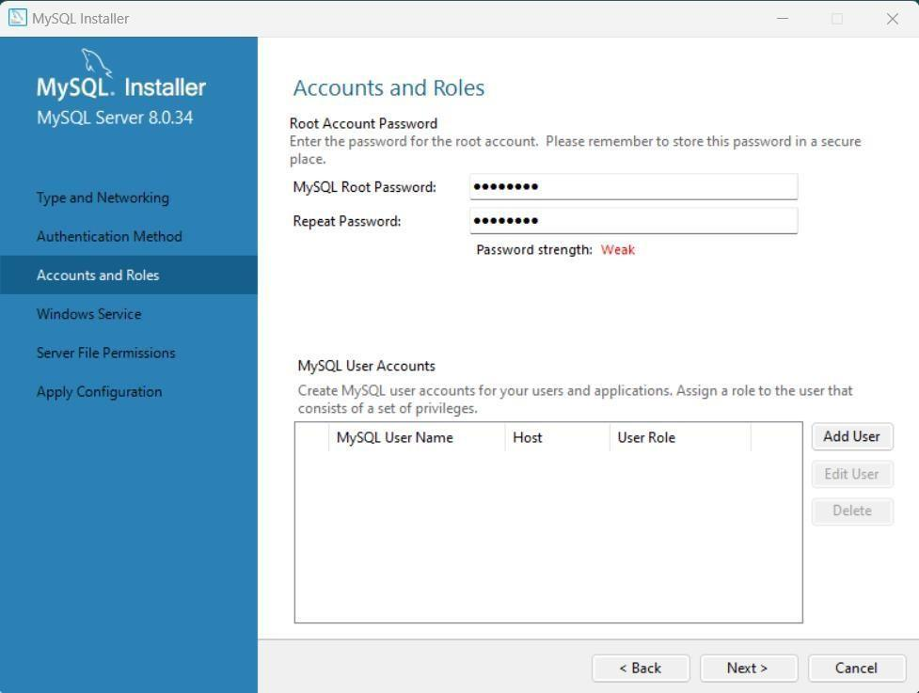

Step 6 : Select a standard configuration and this will use a general purpose configuration for the server that can be tuned manually. To continue, click next.

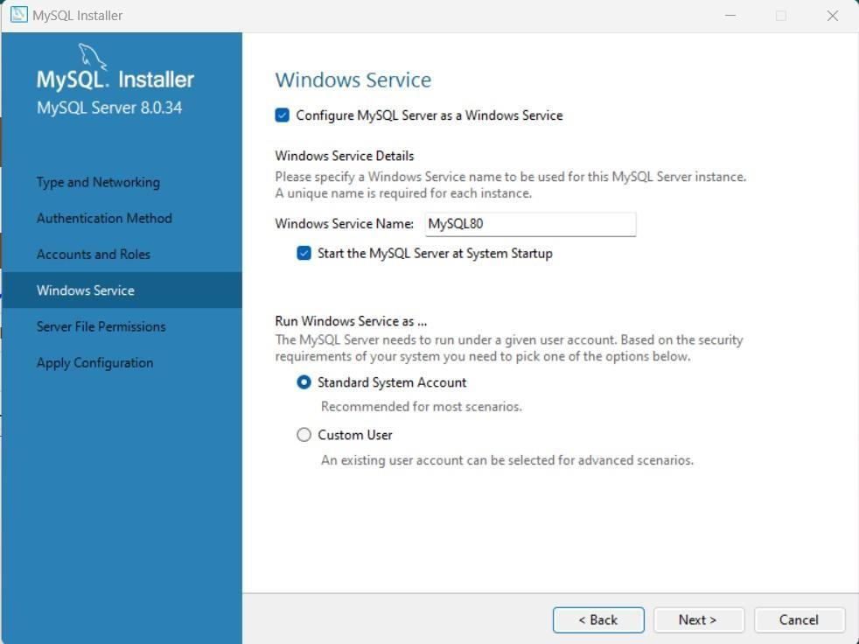

Step 7: To continue, click next.

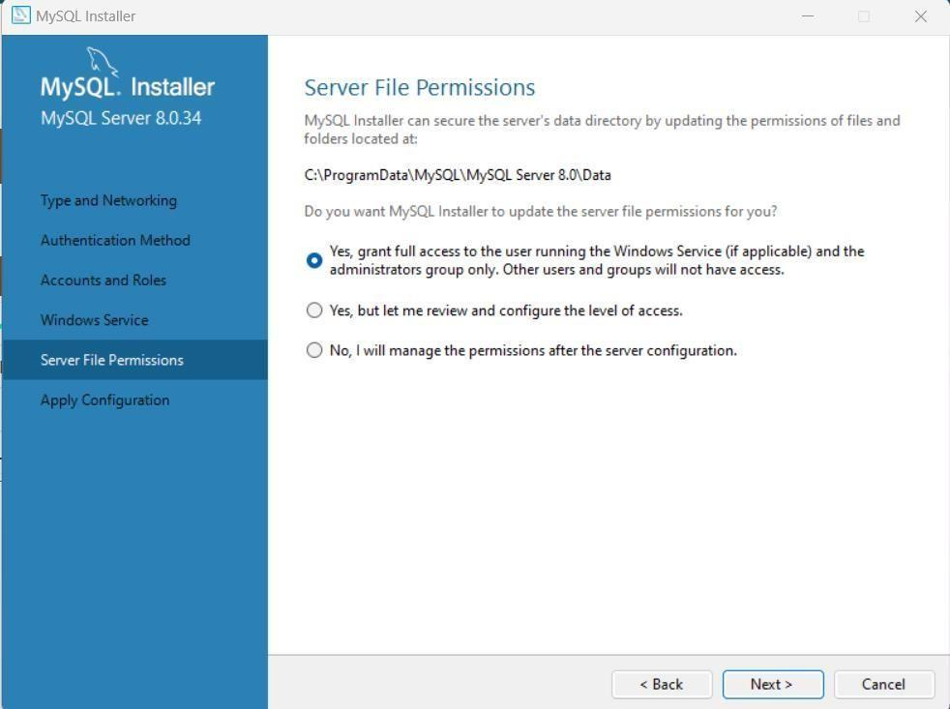

Step 8 : Configuration file created. Windows service MySQL 8.0.34 installed. Press finish to close the wizard .

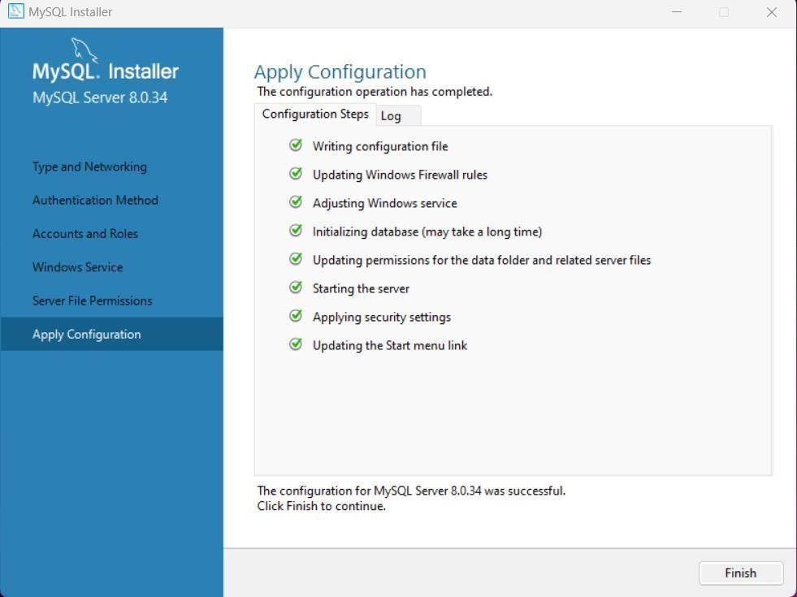

Step 9 : Windows service MySQL 8.0.34 installed. Press finish to close the wizard .

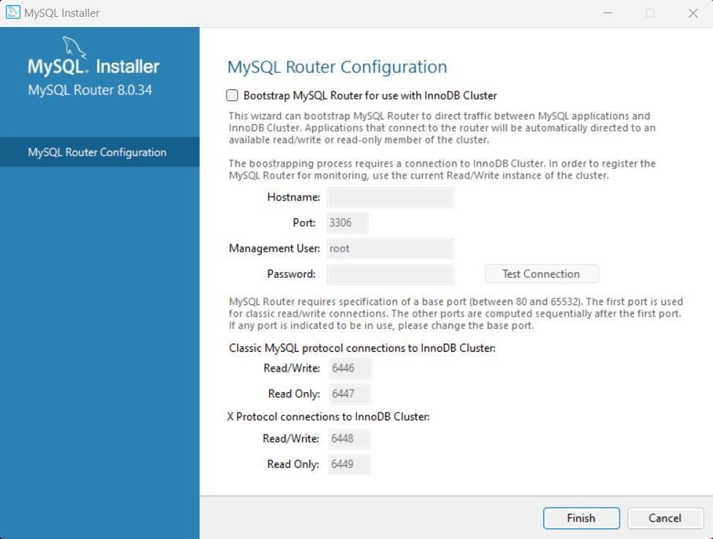

Step 10: Enter the MySQL Password and click on check and then click on next button to continue .

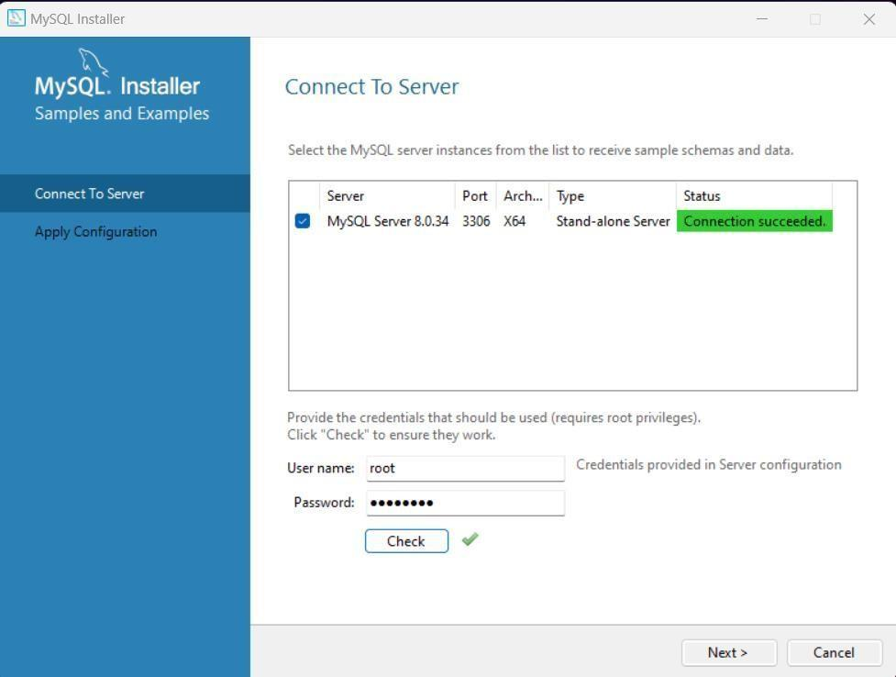

Step 11: Enter the new connection name and click on OK then close the tab.

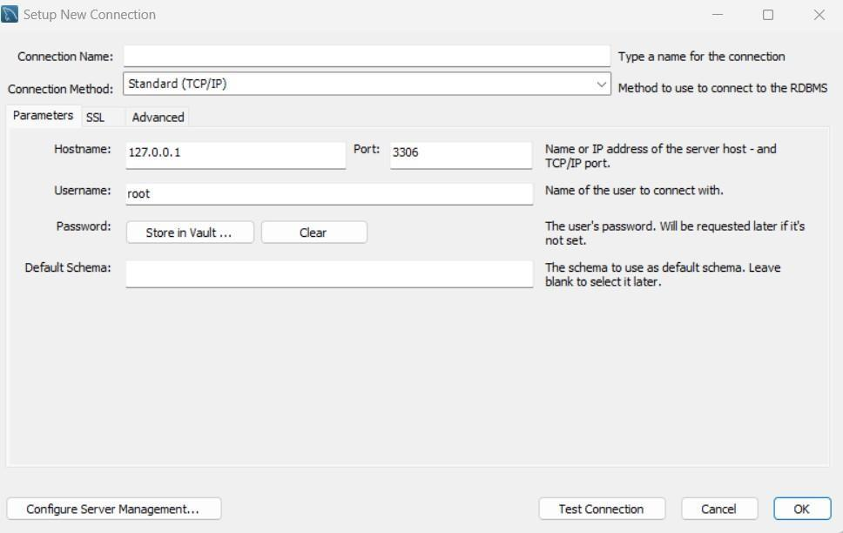

Step 12 : Open MySQL 8.0 Command Line Client and let’s ready for work on MySQL Server 8.0.34.

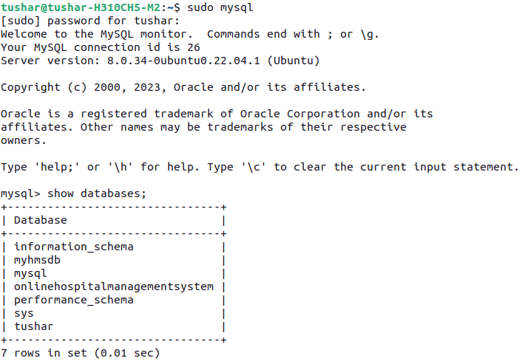

## Experiment No – 02

AIM: Creating Entity-Relationship Diagram usingcase tools.

### HOSPITAL MANAGEMENT SYSTEM

#### Step1: First of all we need to choose the number of entities (object with physical existence or conceptual existence)

* In hospital management system there are 3 major entities:

#### Doctors

* + Patients

#### Medicine

Step2: We should write the attributes associated with each entity.

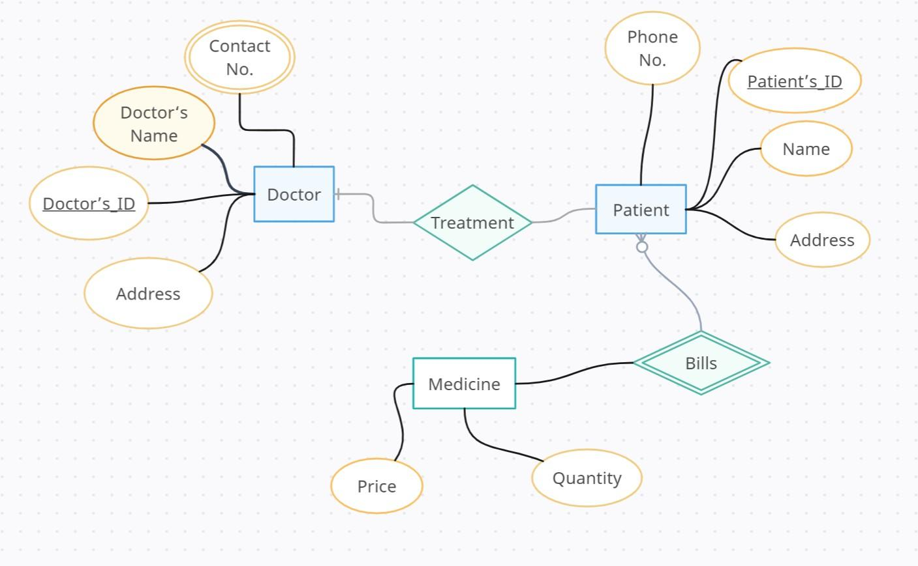

Fig: Entity- Relationship Diagram

## Experiment No – 03

AIM: Prepare Sample Data To Practice SQL Skill.

Table 1: Worker.

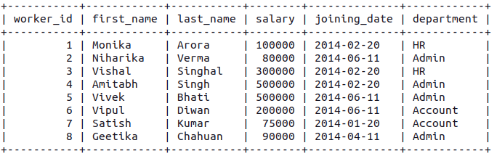

Table 2: Bonus

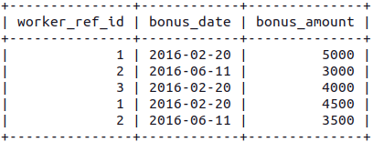

Table 3: Title

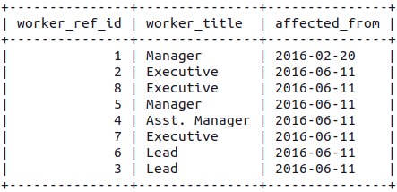

**Queries**

Q-1. Write an SQL query to fetch “FIRST_NAME” from the Worker table using the alias name <WORKER_NAME>.

Ans. SELECT first_name as "worker_name" FROM worker;

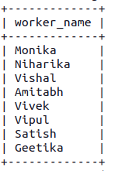

Q-2. Write an SQL query to fetch “FIRST_NAME” from the Worker table in upper case.

Ans. SELECT UPPER(first_name) as "worker_name" FROM worker;

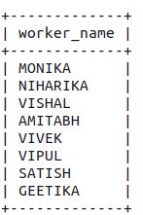

Q-3. Write an SQL query to fetch unique values of DEPARTMENT from the Worker table.

Ans. SELECT DISTINCT department FROM worker;

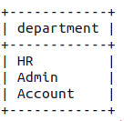

Q-4. Write an SQL query to print the first three characters of FIRST_NAME from the Worker table.

Ans. SELECT SUBSTR(first_name, 1, 3) as "first_name" FROM worker;

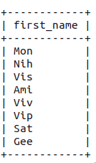

Q-5. Write an SQL query to find the position of the alphabet (‘a’) in the first name column ‘Amitabh’ from the Worker table.

Ans. SELECT LOCATE('a', first_name, 2) as "'a' position" FROM worker WHERE first_name= 'Amitabh';

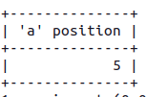

Q-6. Write an SQL query to print the FIRST_NAME from Worker table after removing white spaces from the right side.

Ans. SELECT RTRIM(first_name) FROM worker;

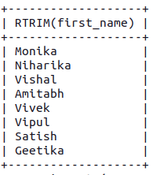

Q-7. Write an SQL query to print the DEPARTMENT from Worker table after removing white spaces from the left side.

Ans. SELECT LTRIM(department) as department FROM worker;

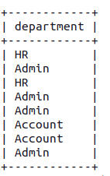

Q-8. Write an SQL query that fetches the unique values of DEPARTMENT from Worker table and prints its length.

Ans. SELECT DISTINCT department, LENGTH(department) as "length" FROM worker;

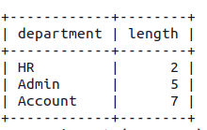

Q-9. Write an SQL query to print the FIRST_NAME from Worker table after replacing ‘a’ with ‘A’.

Ans. SELECT REPLACE(first_name, 'a', 'A') as first_name FROM worker;

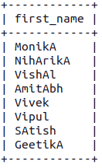

Q-10. Write an SQL query to print the FIRST_NAME and LAST_NAME from Worker table into a single column COMPLETE_NAME. A space char should separate them.

Ans. SELECT CONCAT_WS(" ", first_name, last_name) as 'full_name' FROM worker;

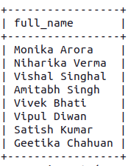

Q-11. Write an SQL query to print all Worker details from the Worker table order by FIRST_NAME Ascending.

Ans. SELECT * FROM worker ORDER BY first_name;

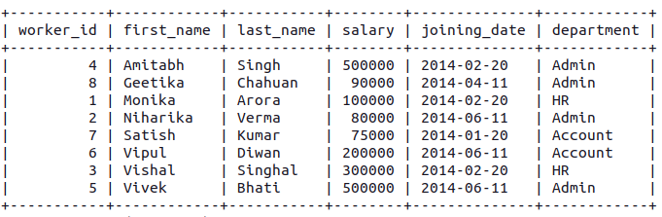

Q-12. Write an SQL query to print all Worker details from the Worker table order by FIRST_NAME Ascending and DEPARTMENT Descending.

Ans. SELECT * FROM worker ORDER BY first_name ASC, department DESC;

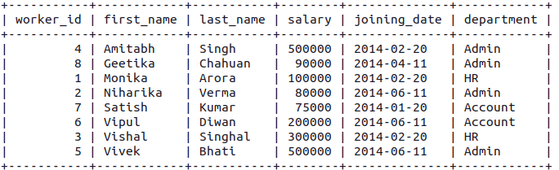

Q-13. Write an SQL query to print details for Workers with the first name as “Vipul” and “Satish” from Worker table.

Ans. SELECT * FROM worker WHERE first_name = "Vipul" or first_name = "Satish";

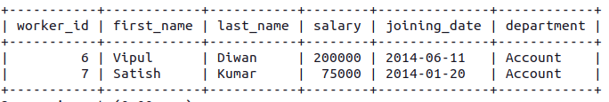

Q-14. Write an SQL query to print details of workers excluding first names, “Vipul” and “Satish” from Worker table.

Ans. SELECT * FROM worker WHERE first_name != "Vipul" AND first_name != "Satish";

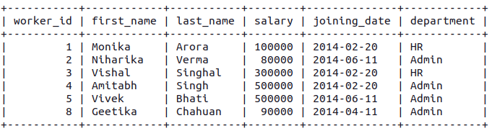

Q-15. Write an SQL query to print details of Workers with DEPARTMENT name as “Admin”.

Ans. SELECT * FROM worker WHERE department = "ADMIN";

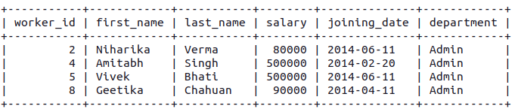

Q-16. Write an SQL query to print details of the Workers whose FIRST_NAME contains ‘a’.

Ans. SELECT * FROM worker WHERE first_name LIKE '%a%';

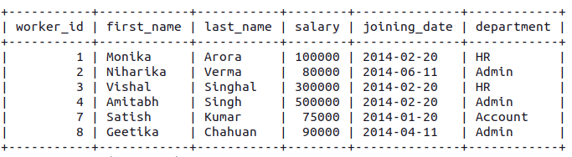

Q-16. Write an SQL query to print details of the Workers whose FIRST_NAME contains ‘a’.

Ans. SELECT * FROM worker WHERE first_name LIKE '%a';

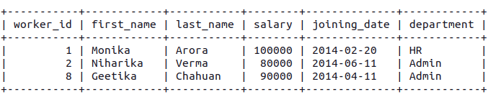

Q-18. Write an SQL query to print details of the Workers whose FIRST_NAME ends with ‘h’ and contains six alphabets.

Ans. SELECT * FROM worker WHERE first_name LIKE '%h' AND LENGTH(first_name) = 7;

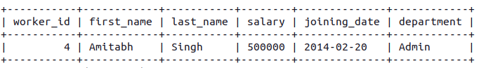

Q-19. Write an SQL query to print details of the Workers whose SALARY lies between 100000 and 500000.

Ans. SELECT * FROM worker WHERE salary BETWEEN 100000 AND 500000;

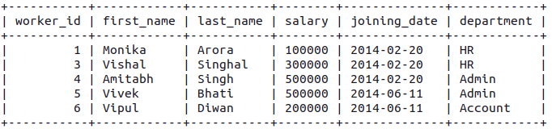

Q-20. Write an SQL query to print details of the Workers who have joined in Feb’2014.

Ans. SELECT * FROM worker WHERE joining_date >= "2014-02-01" AND joining_date <= "2014-02-29";

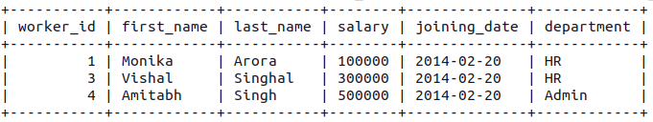

Q-21. Write an SQL query to fetch the count of employees working in the department ‘Admin’.

Ans. SELECT COUNT(*) as "Admin_Count" FROM worker WHERE department="Admin";

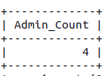

Q-22. Write an SQL query to fetch worker names with salaries >= 50000 and <= 100000.

Ans. SELECT CONCAT_WS(" ", first_name, last_name) as "worker_name", salary FROM worker WHERE salary BETWEEN 50000 AND 100000;

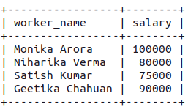

Q-23. Write an SQL query to fetch the no. of workers for each department in the descending order.

Ans. SELECT department, COUNT(department) as "count" FROM worker GROUP BY department ORDER BY count DESC;

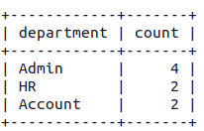

Q-24. Write an SQL query to print details of the Workers who are also Managers.

Ans. SELECT worker_id, first_name, last_name, salary, joining_date, department, affected_from FROM worker INNER JOIN title on worker_ref_id = worker_id AND worker_title = "Manager";

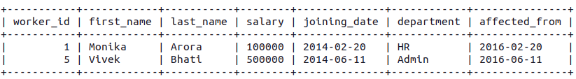

Q-24. Write an SQL query to print details of the Workers who are also Managers.

Ans. SELECT worker_id, first_name, last_name, salary, joining_date, department, affected_from FROM worker INNER JOIN title on worker_ref_id = worker_id AND worker_title = "Manager";



Q-25. Write an SQL query to fetch duplicate records having matching data in some fields of a table.

Ans. SELECT worker_title, affected_from, COUNT(*) as "count" FROM title GROUP BY worker_title, affected_from;

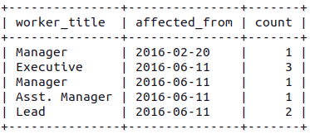

26. Write an SQL query to show only odd rows from a table.

SELECT * FROM worker WHERE worker_id % 2 = 1;

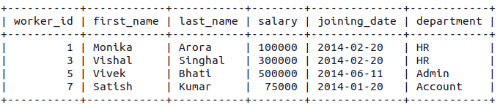

27. Write an SQL query to show only even rows from a table.

SELECT * FROM worker WHERE worker_id % 2 = 0;

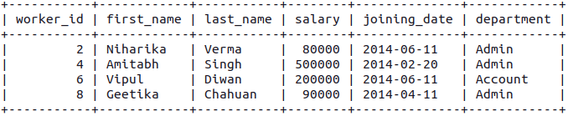

28. Write an SQL query to clone a new table from another table.

CREATE TABLE IF NOT EXISTS worker_copy as SELECT worker_id, CONCAT_WS(" ", first_name, last_name) as 'worker_name', department FROM worker;

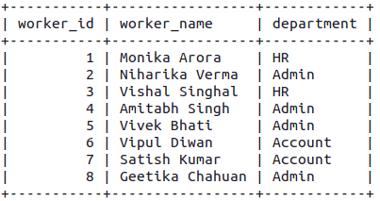

29. Write an SQL query to fetch intersecting records of two tables.

SELECT worker_id, worker_name FROM worker_copy INNER JOIN bonus on worker_ref_id = worker_id;

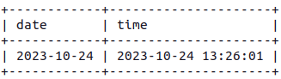

30. Write an SQL query to show records from one table that another

table does not have.

SELECT * FROM worker WHERE worker_id NOT IN (SELECT worker_ref_id FROM bonus);

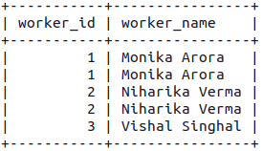

31. Write an SQL query to show the current date and time.

SELECT CURDATE() as "date", NOW() as "time";

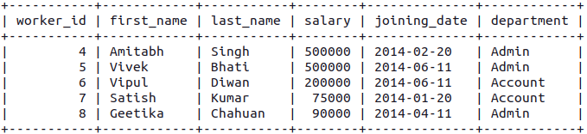

32. Write an SQL query to show the top n (say 10) records of a table.

SELECT * FROM worker ORDER BY salary DESC LIMIT 5;

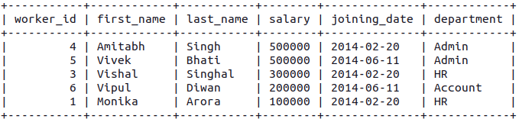

33. Write an SQL query to determine the nth (say n=5) highest salary

from a table.

SELECT * FROM worker ORDER BY salary DESC LIMIT 4, 1;

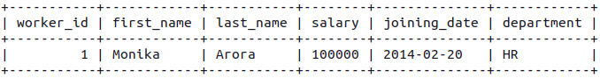

34. Write an SQL query to determine the 5th highest salary without

using TOP or limit method.

SELECT * FROM worker w1 WHERE 4 = (SELECT COUNT(DISTINCT(w2.salary)) FROM worker w2 WHERE w2.salary >= w1.salary);

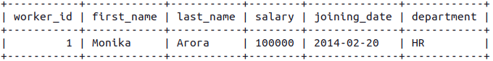

35. Write an SQL query to fetch the list of employees with the same

salary.

SELECT DISTINCT W.worker_id, W.first_name, W.salary FROM worker W, worker W1 WHERE W.salary = W1.salary AND W.worker_id != W1.worker_id;

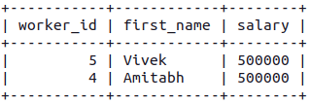

36. Write an SQL query to show the second highest salary from a

table.

SELECT max(salary) FROM worker WHERE salary NOT IN (SELECT max(salary) FROM worker);

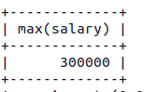

37. Write an SQL query to show one row twice in results from a

table.

SELECT first_name, department FROM worker W WHERE W.department='HR'

UNION ALL SELECT first_name, department FROM worker W1 WHERE W1.department='HR';

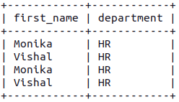

38. Write an SQL query to fetch intersecting records of two tables.

SELECT worker_id, first_name, last_name, worker_title, salary FROM worker INNER JOIN title ON worker_id = worker_ref_id;

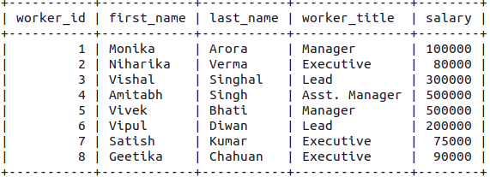

39. Write an SQL query to fetch the first 50% records from a table.

SELECT * FROM worker WHERE worker_id <= (SELECT count(worker_id)/2 FROM worker);

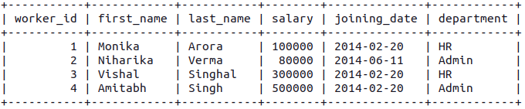

40. Write an SQL query to fetch the departments that have less than

five people in it.

SELECT department, COUNT(worker_id) as 'Number of Workers' FROM worker GROUP BY department HAVING COUNT(worker_id) < 5;

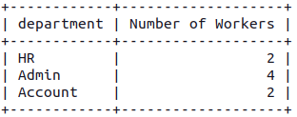

41. Write an SQL query to fetch the departments that have less than

five people in it.

SELECT department, COUNT(department) as 'Number of Workers' FROM worker GROUP BY department;



42. Write an SQL query to show the last record from a table.

SELECT * FROM worker ORDER BY worker_id DESC LIMIT 1;

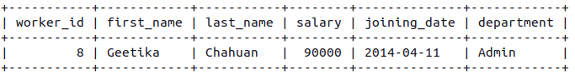

43. Write an SQL query to fetch the first row of a table.

SELECT * FROM worker ORDER BY worker_id LIMIT 1;

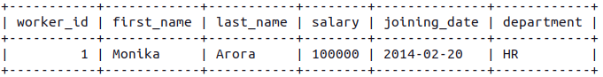

44. Write an SQL query to fetch the last five records from a table.

SELECT * FROM worker ORDER BY worker_id DESC LIMIT 5;

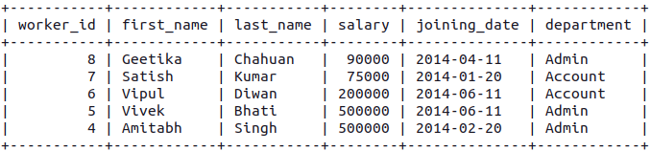

45. Write an SQL query to print the name of employees having the

highest salary in each department.

SELECT t.DEPARTMENT, t.FIRST_NAME, t.Salary FROM (SELECT max(Salary) AS TotalSalary, DEPARTMENT FROM worker GROUP BY DEPARTMENT) AS TempNew INNER JOIN worker t ON TempNew.DEPARTMENT = t.DEPARTMENT AND TempNew.TotalSalary = t.Salary;

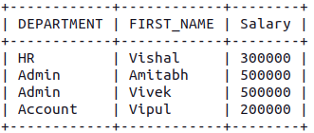

46. Write an SQL query to fetch three max salaries from a table.

SELECT DISTINCT salary FROM worker a WHERE 3 >= (SELECT count(DISTINCT salary) FROM worker b WHERE a.salary <= b.salary) ORDER BY a.salary DESC;

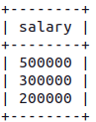

47. Write an SQL query to fetch three max salaries from a table.

SELECT DISTINCT salary FROM worker a WHERE 3 >= (SELECT COUNT(DISTINCT salary) FROM worker b WHERE a.salary >= b.salary) ORDER BY a.salary DESC;

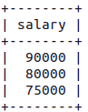

48. Write an SQL query to fetch three max salaries from a table.

SELECT DISTINCT salary FROM worker a WHERE 3 >= (SELECT COUNT(DISTINCT salary) FROM worker b WHERE a.salary <= b.salary) ORDER BY a.salary DESC;

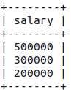

49. Write an SQL query to fetch departments along with the total

salaries paid for each of them.

SELECT department, sum(salary) FROM worker GROUP BY department;

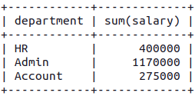

50. Write an SQL query to fetch the names of workers who earn the

highest salary.

SELECT first_name, salary FROM worker WHERE salary=(SELECT max(salary) FROM worker);

